**Tutorial Session**

1. Find the all pairs shortest path of the following graph.

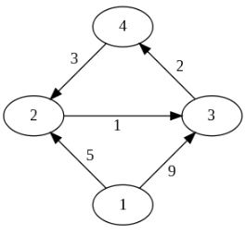

1. Find the minimum spanning tree of the following graph using both prims and kruskal’s algorithm.

